**Unsupervised Learning**

**K-Prototype Clustering**

Modelling process → Similar to K-means, however, it allows the usage of both numeric and categorical variables in the same model allowing us to capture the relationships between them. As such, to determine the number of clusters we create a chart showing the dispersion between the clusters and select the elbow as this is where the drop in dispersion is the most.

**Elbow Chart**

**Insights from the Charts**

**Cluster Insights**

1. **Cluster 1**:
   * Predominantly males from QLD.
   * Non-smokers with annualised premium payments.
   * Higher likelihood of having life, TPD, trauma, and IP covers.
2. **Cluster 2**:
   * Predominantly males from NSW.
   * Non-smokers with monthly premium payments.
   * Higher income compared to other clusters.
   * High likelihood of having all types of insurance coverages.
3. **Cluster 3**:
   * Predominantly males from VIC.
   * Non-smokers with monthly premium payments.
   * Average income with less comprehensive coverage (only IP).
4. **Cluster 4**:
   * Predominantly females from NSW.
   * Non-smokers with yearly premium payments.
   * Lower income compared to Cluster 2.
   * Likely to have life and TPD coverage, less likely to have trauma and IP.

**Some charts**

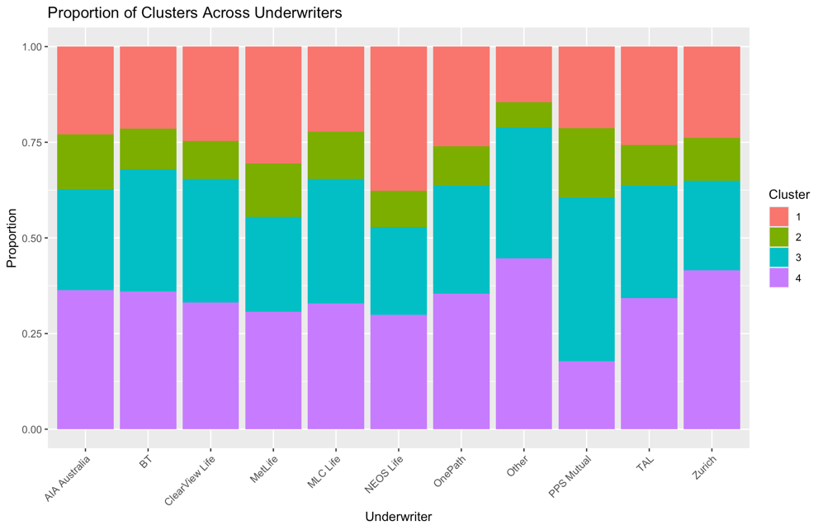

**Age Distribution by Underwriter and Cluster**:

* The age distribution across underwriters is relatively similar within each cluster, indicating that age might not be the primary differentiator for NEOS Life compared to other underwriters. However, consistent age distribution across clusters suggests that products might be effectively targeted to specific age groups within each cluster.

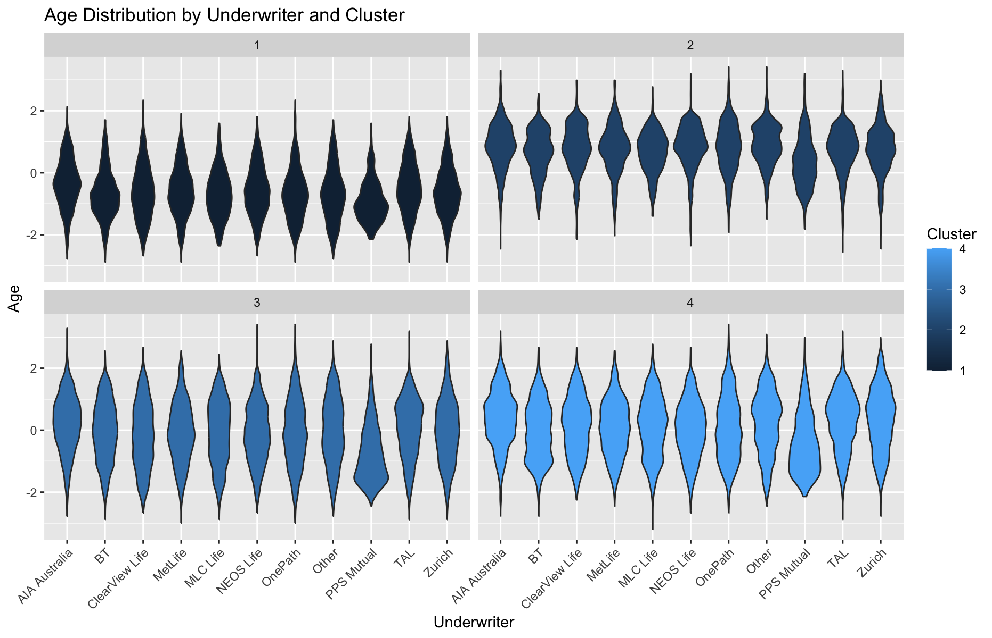

**Income Distribution by Underwriter and Cluster**:

* The income distribution shows more variability, especially in the higher income brackets where NEOS Life appears to have less representation compared to underwriters like BT and Zurich in certain clusters. This could suggest a potential area to enhance NEOS Life's offerings or marketing strategies to appeal more to higher-income individuals.

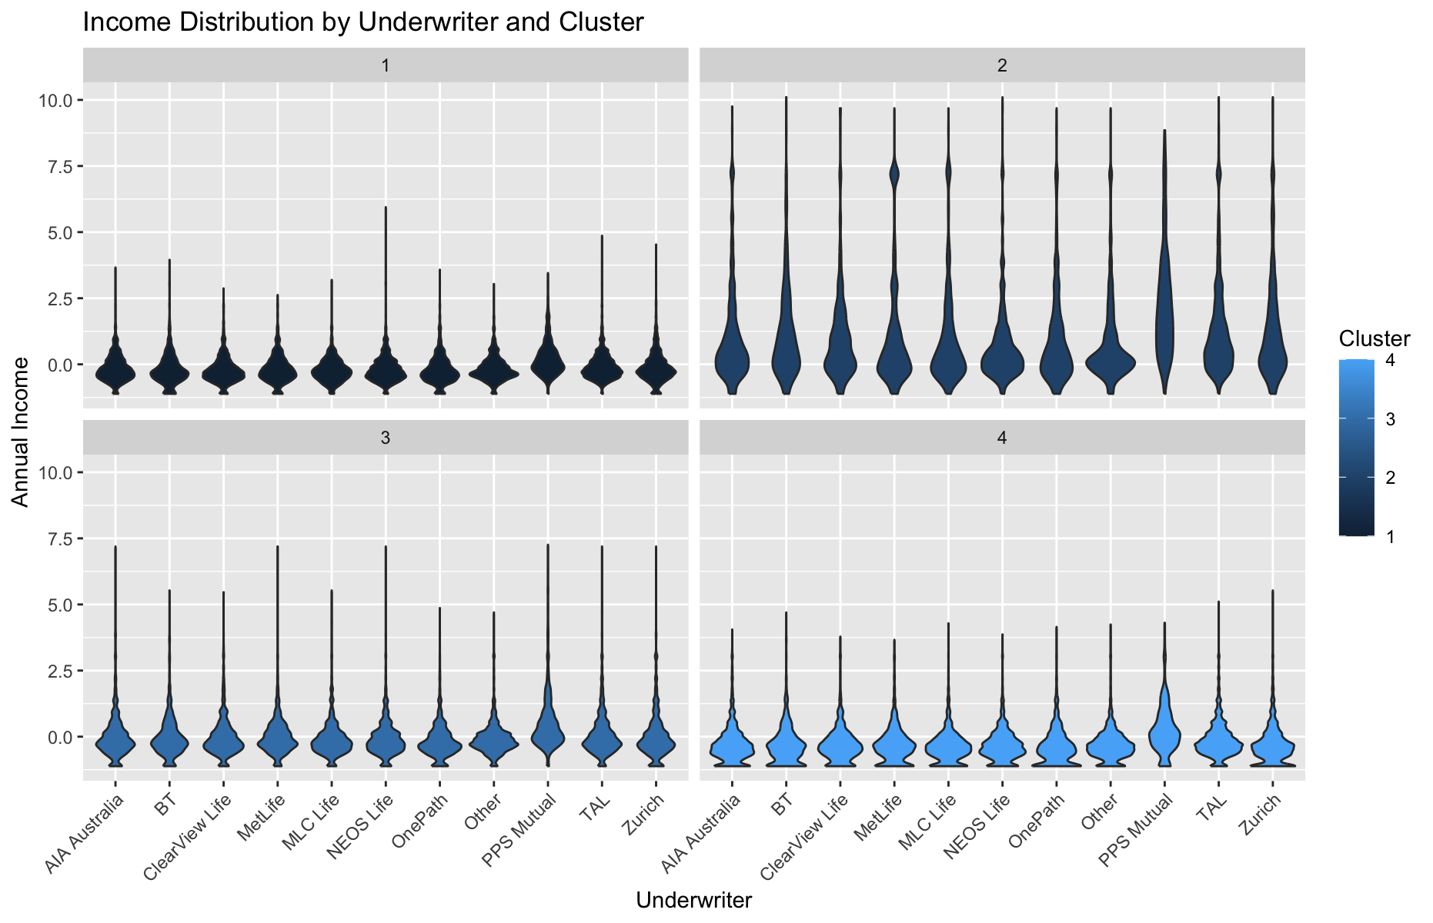

**Annualised Premium Distribution by Underwriter and Cluster**:

* NEOS Life appears to have competitive annualized premium rates across most clusters, although their premiums are not the highest, indicating that they are not necessarily seen as a premium brand. Consider adjusting premium structures or enhancing value propositions for segments where NEOS Life is underperforming.

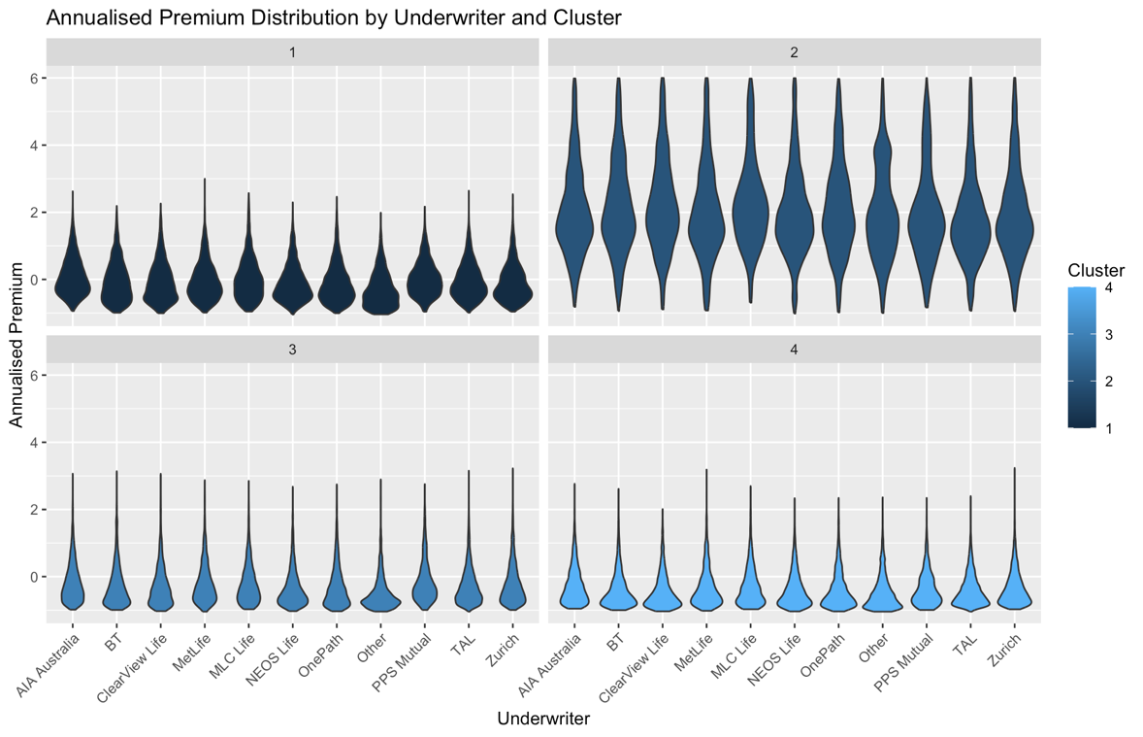

**Age vs Annual Income Scatter Plots**:

* These plots show that NEOS Life covers a good range of age and income, but lacks in the higher income and younger age group, which could be a lucrative market segment. It might be beneficial for NEOS Life to develop targeted products or marketing campaigns for this demographic.

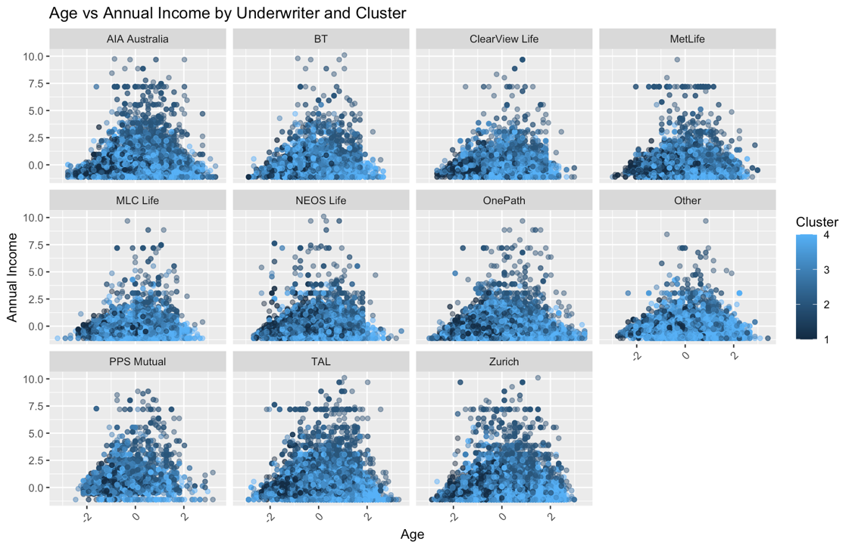

**Box Plot of Annualised Premium by Underwriter and Smoker Status**:

* Smokers generally pay higher premiums across all underwriters. NEOS Life's premium range for smokers isn't the highest, which might make them attractive to price-sensitive customers, but could also mean they are leaving money on the table by not differentiating enough based on risk.

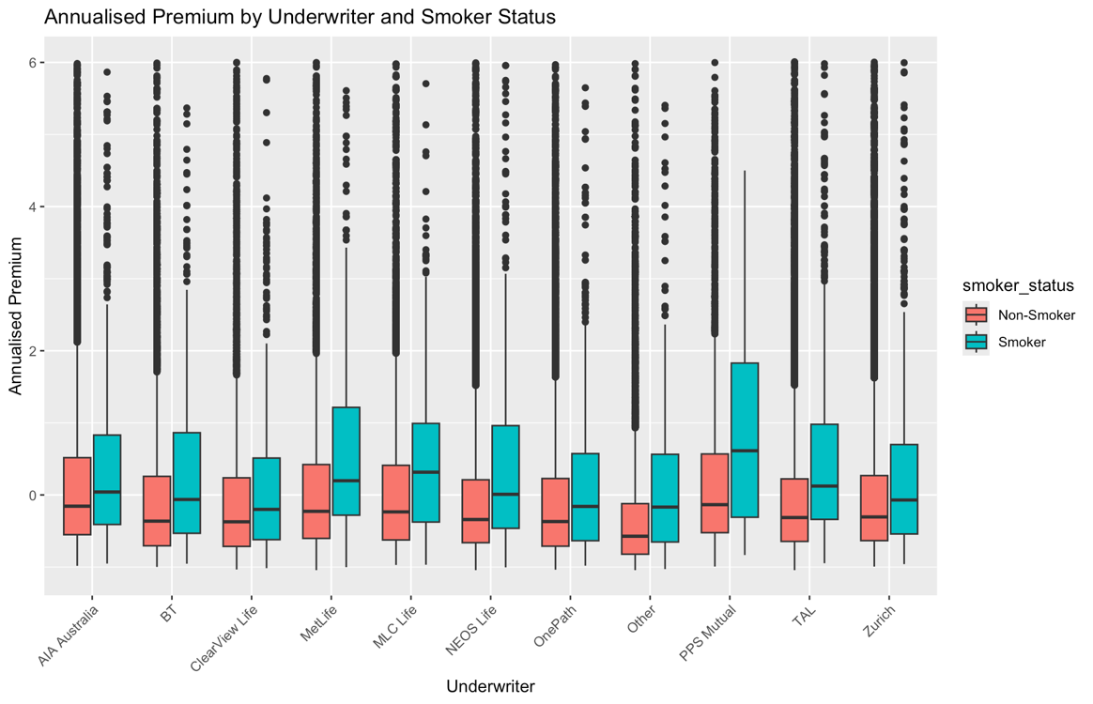

**Basic Recommendations based upon the above graphs – elements of this can be used in speech/ final recommendations etc.**

1. **Target High-Income Young Adults**:
   * Given the gap in the younger, high-income segment, NEOS Life could consider developing or promoting products tailored to the lifestyle and financial needs of this demographic, such as premium life insurance packages with enhanced benefits.
2. **Enhance Product Offerings**:
   * Introduce or highlight unique selling propositions that cater to the specific needs of different clusters, particularly those where NEOS Life has less presence. This could include wellness programs, flexible premium payments, or bundled insurance packages.
3. **Marketing Strategy**:
   * Adjust marketing strategies to focus more on digital channels to target younger demographics and use data-driven marketing to personalize messages based on the preferences and behaviors shown in different clusters.
4. **Competitive Premium Structuring**:
   * Reevaluate the premium structure for higher risk categories, like smokers, to ensure competitiveness while also reflecting the increased risk adequately. This could improve profitability in segments that are typically higher risk.
5. **Customer Segmentation**:
   * Further refine customer segmentation by combining demographic data (like age and income) with other lifestyle indicators or preferences that could be derived from the clusters. This deeper segmentation can help NEOS Life develop more targeted products and marketing strategies.

By focusing on these areas, NEOS Life can strategically position themselves in the market to attract segments that are currently under-served or where they have competitive advantages. This strategic approach can help in increasing their market share and overall brand positioning.

**Product Penetration Chart**

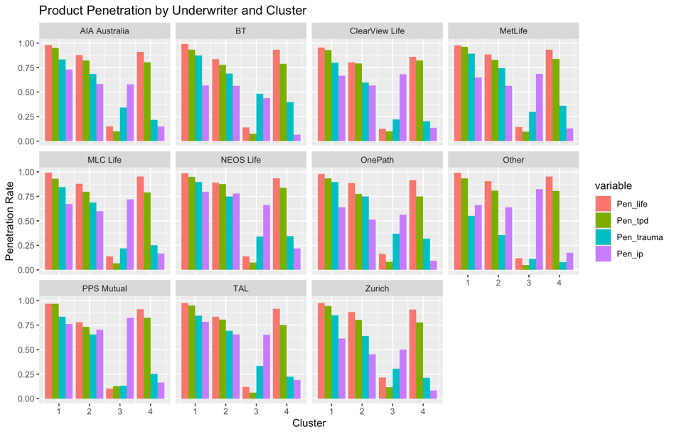

**Key Observations:**

1. **High Penetration in Clusters 1 and 4 for NEOS Life**:
   * NEOS Life has strong penetration rates for life and TPD insurance in Clusters 1 and 4, competitive with leading insurers like AIA Australia and BT.
   * However, Trauma and IP insurances show variability—particularly in Cluster 4, where both are substantially lower than life and TPD. This suggests an opportunity to increase these rates to match the high penetration of other products.
2. **Lower Penetration in Cluster 3**:
   * Cluster 3 shows markedly lower penetration across all products for NEOS Life, indicating a significant gap in market coverage. This is consistent across most insurers, suggesting that Cluster 3 might generally be challenging but also a potential growth area if effectively targeted.
3. **Competitive Comparison in Cluster 2**:
   * NEOS Life has a reasonably good penetration rate in Cluster 2, especially for life and TPD insurance, closely trailing or matching other top insurers like Zurich and TAL. However, Trauma and IP are lower compared to its life and TPD rates, and there might be an opportunity to improve these figures.

**Recommendations:**

1. **Enhance Cluster 3 Focus**:
   * **Targeted Campaigns**: Given the universally low penetration rates in Cluster 3, develop targeted marketing campaigns that address potential barriers to insurance uptake in this cluster. Consider innovative product features or financial incentives that cater specifically to the needs or concerns of this group.
2. **Boost Trauma and IP in Cluster 4**:
   * **Awareness and Education**: Implement programs to increase awareness about the benefits of Trauma and IP insurances, especially in Cluster 4 where the uptake is notably low. Use testimonials, case studies, or data-driven content to highlight the value and importance of comprehensive coverage.
   * **Bundling Offers**: Create attractive bundling offers that combine Trauma and IP with the already popular Life and TPD insurances at a discounted rate to encourage uptake.
3. **Leverage Strong Performance in Clusters 1 and 4**:
   * **Customer Retention**: Since NEOS Life shows strong penetration in Clusters 1 and 4 for certain products, focus on customer retention strategies in these areas. Enhance service quality, customer engagement, and periodic reviews of customer needs to ensure high satisfaction and renewal rates.
4. **Competitive Analysis for Cluster 2**:
   * **Product Differentiation**: Given the competitive nature of Cluster 2, NEOS Life should focus on differentiating their Trauma and IP products from competitors. This could be through unique features, superior customer service, or more competitive pricing strategies.

By focusing on these tailored strategies based on specific clusters and product lines, NEOS Life can not only improve its overall market penetration but also better compete against other key players in the insurance industry.

**Market Share Chart Analysis**

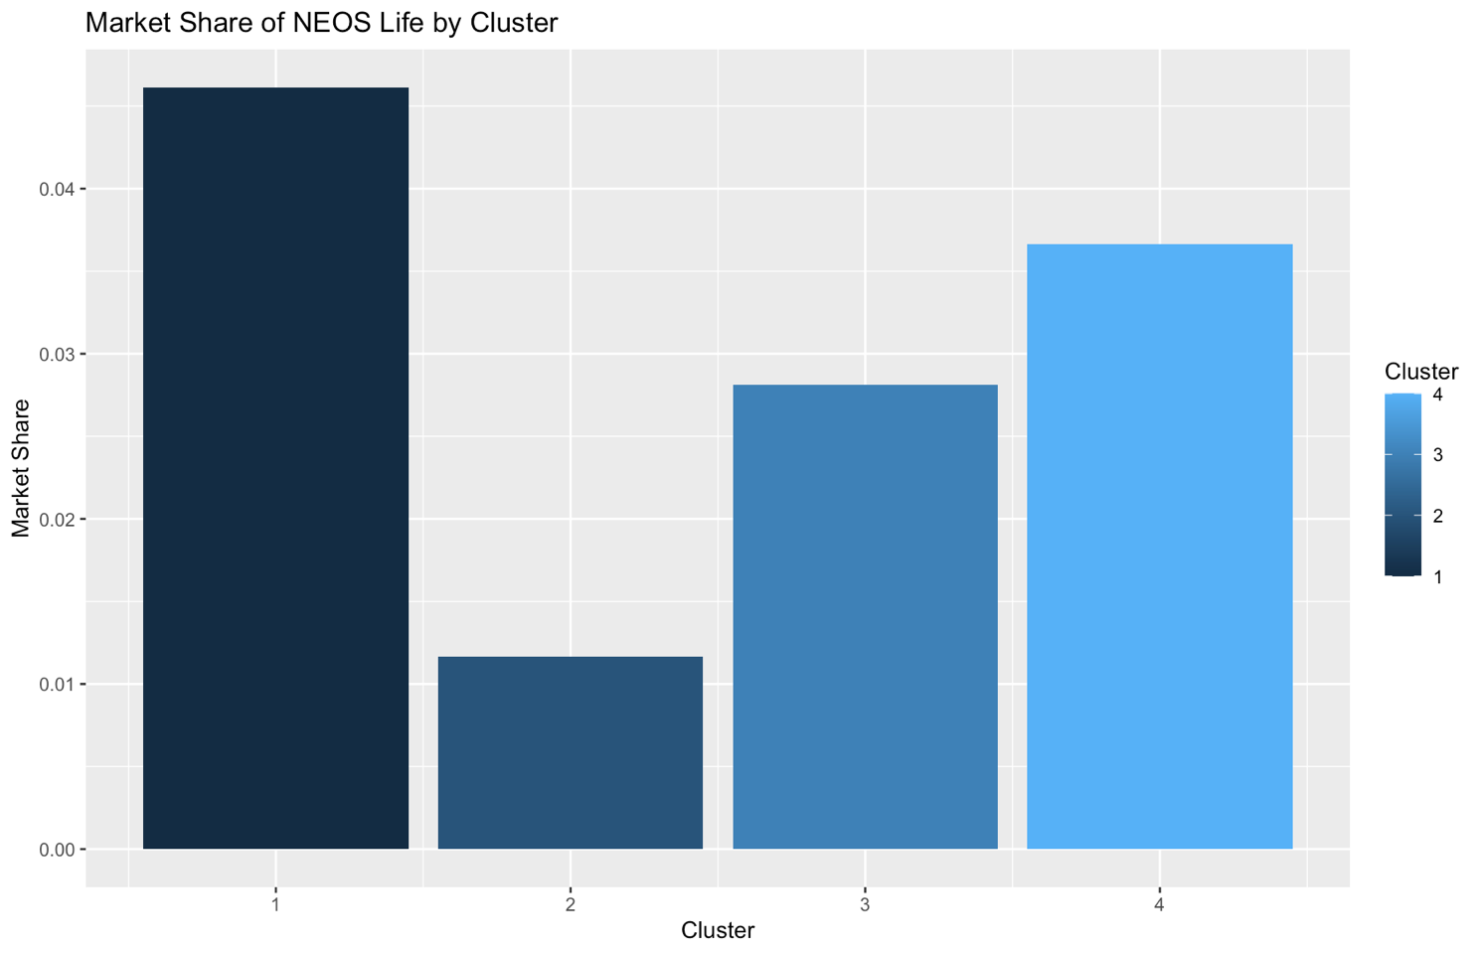

The chart clearly depicts the market share of NEOS Life across four clusters:

* **Cluster 1**: NEOS Life has a strong market share, indicating a solid foothold. This suggests effective targeting or product alignment with the needs of this cluster.
* **Cluster 2**: There's a noticeable drop in market share compared to Cluster 1. This indicates either increased competition, less effective targeting, or potential mismatches in product offerings for the needs of this cluster.
* **Cluster 3**: The market share is somewhat higher than in Cluster 2 but still not as high as in Cluster 1. This could be due to partial effectiveness of NEOS Life's strategies or moderate competition.
* **Cluster 4**: Shows a significant increase in market share, nearly matching Cluster 1. This suggests strong performance and possibly effective marketing or product suitability for this cluster’s needs.

**Strategic Implications and Recommendations**

* **Cluster 1 and 4**: High market share in these clusters indicates effective engagement. NEOS Life should focus on maintaining its strong position here by continuing to deliver high customer satisfaction, monitoring competitor moves, and potentially leveraging successful strategies from these clusters as case studies to replicate in others.
* **Cluster 2**:
  + **Focused Improvement**: Given the lower market share, NEOS Life should investigate the specific needs and preferences of this cluster. Enhance marketing efforts, tailor products more closely to their needs, or adjust pricing strategies to be more competitive.
  + **Competitive Analysis**: Conduct a thorough analysis of competitors who are performing well in this cluster to understand their strategies and product offerings.
* **Cluster 3**:
  + **Moderate Enhancement**: Since the performance here is between the highs of Clusters 1 and 4 and the low of Cluster 2, targeted improvements can be made. This might involve increasing promotional activities, improving customer engagement, or revisiting the distribution channels used in this cluster.

**Actions to Take**

1. **Customer Insight Gathering**: Conduct surveys or focus groups in Clusters 2 and 3 to gain deeper insights into why NEOS Life's market share might be lower. Understand customer perceptions, competitor preferences, and any potential barriers to choosing NEOS Life.
2. **Product and Pricing Review**: Review the product features and pricing strategies in Clusters 2 and 3. Ensure they align with the demographic and economic characteristics of these clusters.
3. **Marketing Strategy Revision**: Revise marketing strategies to increase visibility and attractiveness of NEOS Life's offerings in underperforming clusters. This could involve targeted campaigns, offers, or even community engagement initiatives based on the specific cluster characteristics.
4. **Performance Tracking**: Establish metrics to regularly track the performance of revised strategies in Clusters 2 and 3 to ensure that adjustments are yielding the desired improvements in market share.

By focusing on these strategies, NEOS Life can work to improve its market position in clusters where it currently underperforms and solidify its standing where it already does well.

**Associate Rules Analysis**

**Interpretation of the Rules:**

1. **Strong Positive Associations for TPD Insurance**:
   * Rules 2, 3, 4, 5, 6, 7, 8, 9, 10 strongly suggest that there's a significant association between having Life, IP, and Trauma insurances and purchasing TPD insurance. High confidence in these rules (around 0.9 or higher) indicates that customers who have one or more of these insurances are very likely to also have TPD insurance.
2. **Life Insurance as a Common Element**:
   * Life insurance appears frequently as a consequent, especially where other products are bundled (rules 6, 7, 8, 10, 11, 12). This implies a high probability that customers with other types of insurance also opt for Life insurance.
3. **Negative Association for Having Only Life Insurance**:
   * Rule 1, where the absence of TPD (and presence of only Life) predicts the absence of other insurances with considerable support and confidence, suggests that customers with only Life insurance might be less inclined to purchase additional covers.

**Make a table for this? Pretty good lift for some of these.**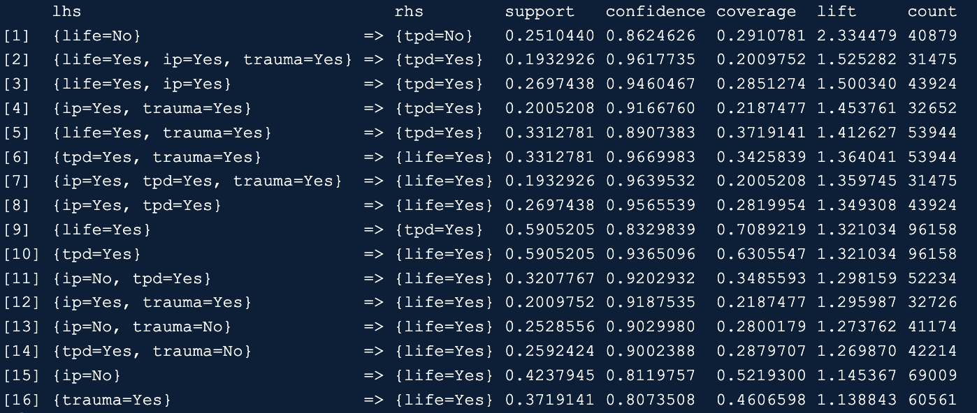

**Insights from Graphs:**

1. **Scatter Plot (Support vs Confidence)**:
   * Shows that most rules with high confidence have moderate support, suggesting these rules are strong and relevant to a significant portion of your customers.

1. **Grouped Matrix Plot**: not a good plot
   * This plot emphasises how frequently different combinations of products appear in the rules, particularly highlighting that combinations involving TPD insurance and Life insurance are prevalent.
2. **Graph-Based Visualisation**: not a good plot
   * Illustrates the connections between different products. The dense connections between IP, Life, and TPD, and somewhat with Trauma, suggest these are often considered together by customers.
3. **Parallel Coordinates Plot**: again, not a good plot
   * This plot highlights the consistent high confidence across rules involving multiple products leading to the purchase of Life or TPD insurance.

**Recommendations for Product Packaging:**

1. **Bundle TPD with Life and Trauma Insurances**:
   * Given the high association of TPD with other insurances, consider creating bundled offerings where TPD is packaged with Life and possibly Trauma insurance.
2. **Promote Life Insurance as a Base Product**:
   * Since Life insurance frequently appears as a consequent, promote it actively as a base product to which customers can add other types of coverages.
3. **Targeted Marketing for Combinations**:
   * Use the insights from the rules to target marketing campaigns. For example, customers who have either Life or IP might be targeted for upgrades or cross-sells with TPD or Trauma coverages.
4. **Customisable Packages**:
   * Offer flexibility in packaging, allowing customers to pick and choose add-ons to a base Life insurance product, thus capitalising on the natural associations shown in your data.

These strategies should help in structuring your product offerings in a way that aligns with customer preferences and behaviours, potentially increasing uptake and satisfaction. If you have further specific questions or need more detailed advice on implementing these strategies, feel free to ask!